SUMMERVILLE CREDIT UNION · CONSOLIDATED MEMBER GUIDE
Spending Limits

Module: nFinia Digital Banking > Cards > Card Details > Card Controls > Spending Limits
01 PRODUCT SUMMARY

The Spending Limits feature gives you control over how much can be spent on your card within a given period. You can set per-transaction and per-month spending caps that will automatically decline any transaction exceeding the specified amounts.
Spending limits are found under Card Controls in the Card Details view. Each limit can be toggled on or off independently. When enabled, you enter a dollar amount that defines the maximum allowable spend for that period. This feature is particularly useful for managing budgets, controlling secondary cardholder spending, or adding a layer of fraud protection.

At a Glance
Attribute | Detail
Module | nFinia Digital Banking > Cards > Card Details > Card Controls > Spending Limits
Per Transaction Limit | Declines any single transaction exceeding the set amount
Per Month Limit | Declines transactions once the monthly spend cap is reached
Toggle | Each limit can be independently enabled or disabled
Related Features | Location Controls, Card Alerts, Usage Control

02 KEY USE CASES

Use Case | Who Uses It | What They Do | Business Value
Cap per-transaction spend | Member managing a shared or secondary card | Enables Per Transaction limit and sets a maximum dollar amount | Prevents large unexpected charges on the card
Set a monthly budget | Member tracking monthly expenses | Enables Per Month limit with a target spending cap | Card automatically declines transactions once the monthly cap is hit
Disable a limit | Member who no longer needs a cap | Toggles the limit off from the Spending Limits screen | Card resumes normal transaction behavior without a spending cap

03 STEP-BY-STEP GUIDE

Navigation: Log in to Summerville Credit Union online banking. From the Dashboard, click Cards, select your card, click Card Controls, then select Spending Limits.
Step 1 — Arrive at the Dashboard
After logging in, you land on the Dashboard. Click Cards in the top navigation to open your card list, then select the card you want to configure. From Card Details, click Card Controls to open the controls panel.
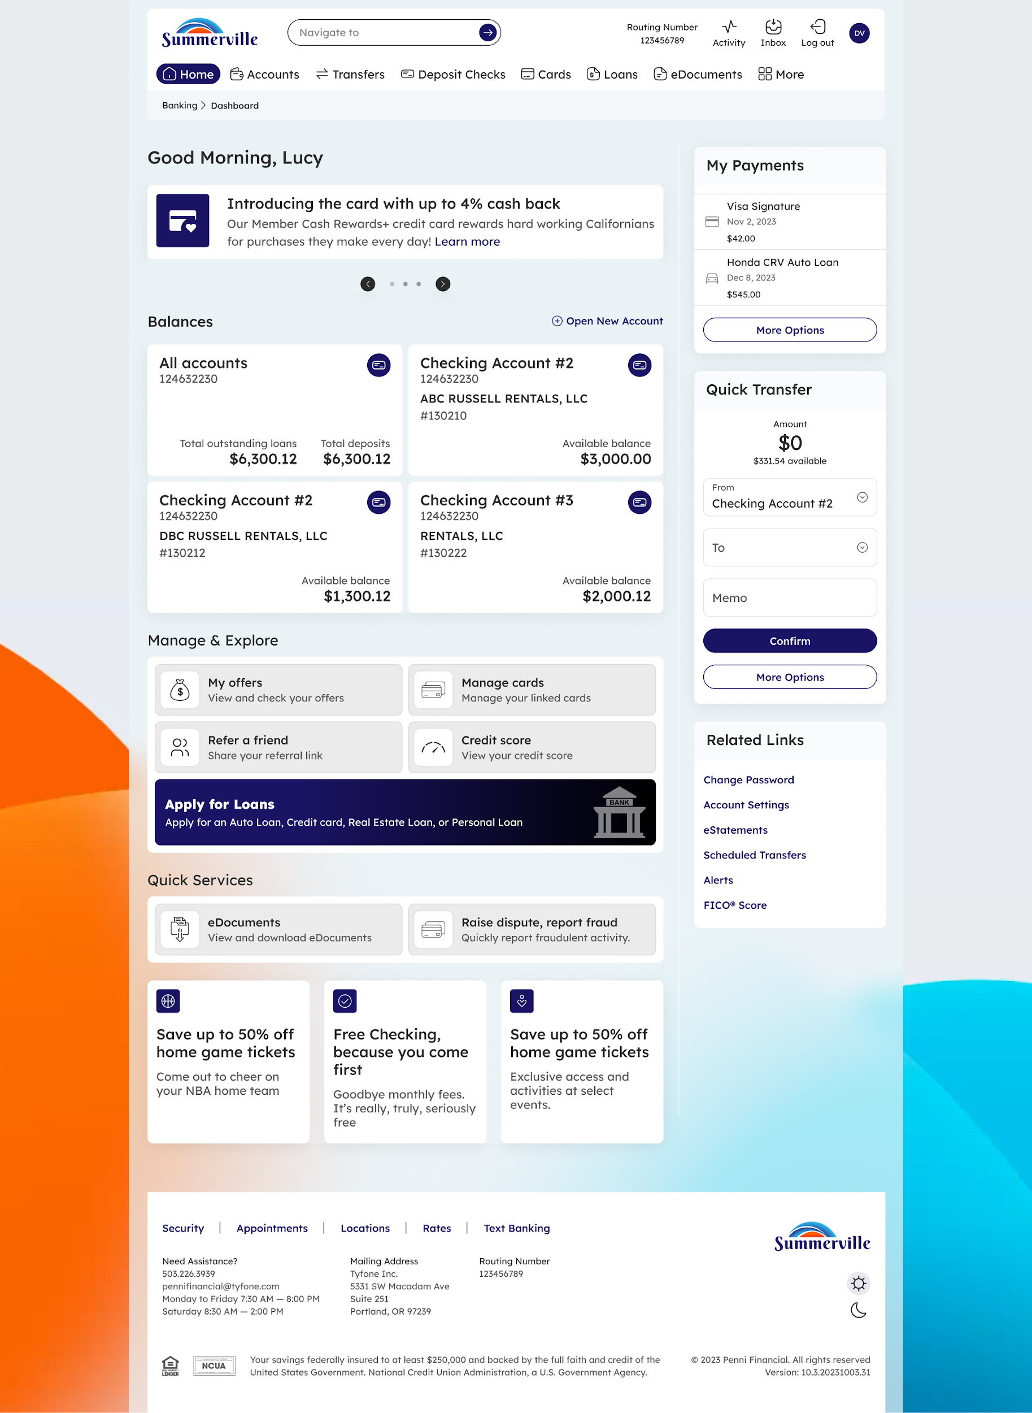
Step 1: Dashboard — click Cards to begin
Step 2 — Configure Spending Limits
The Spending Limits tab opens under Card Controls. You will see two limit types: Per Transaction and Per Month. Toggle either limit on to activate it, then enter the maximum dollar amount in the input field. For Per Month, your current monthly spend is shown for reference. Toggle a limit off at any time to remove it. Changes take effect immediately.
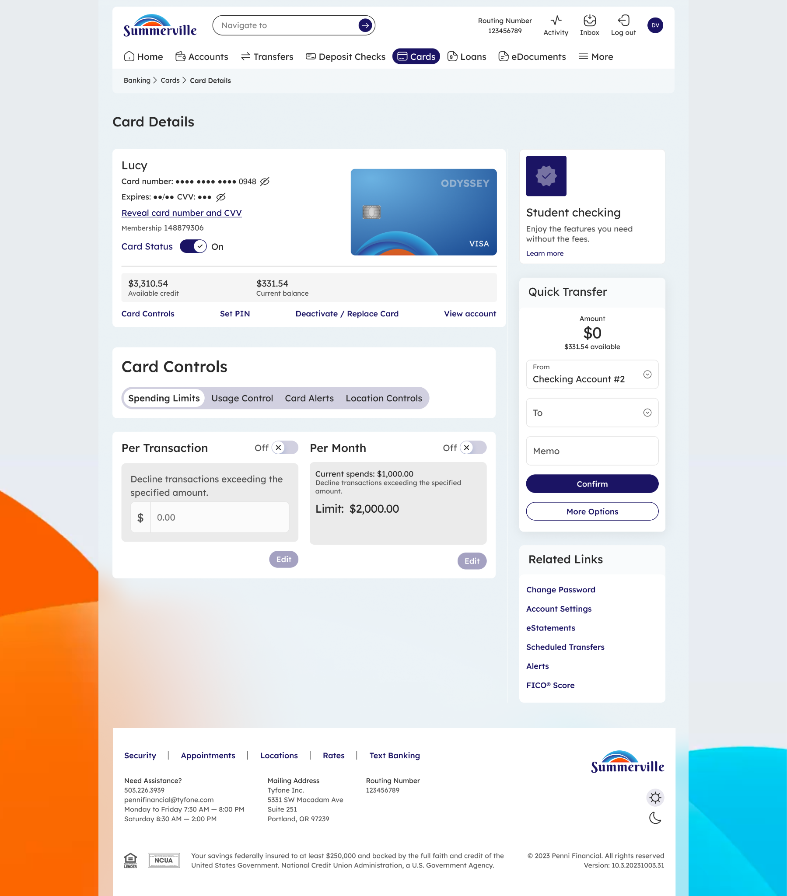
Step 2: Set per-transaction and per-month spending limits for your card

